**Risk tolerance using fuzzy logic: a more accurate method for assessing risk**

**tolerance and optimizing capital portfolios**

**AMIRSHAYAN JALILI**

[**SHAYAN138190@GMAIL.COM**](mailto:SHAYAN138190@GMAIL.COM)

**+989101943345**

**Abstract :**

This article pays special attention to risk tolerance in decision-making processes, especially in sensitive economic and financial fields. Risk tolerance has traditionally been evaluated using precise methods and indicators and inefficiency in predetermined, which may lead to the inaccuracy of important decisions. This is where fuzzy logic as an effective and dynamic tool provides

a more efficient approach with a wider and more accurate approach to risk tolerance assessment.

In this article, the use of fuzzy logic in the assessment of risk tolerance of people has been investigated. using

Fuzzy sets and fuzzy inference systems, a new proposed framework for solving

provides ambiguities and uncertainty related to risk tolerance. This approach makes the evaluation much better

More accurate and comprehensive risk tolerance can be obtained and by using fuzzy logic, the incomplete and complex information involved in risk tolerance analysis can be managed more precisely.

The results of this research showed that parameters such as the age of the investor, the investment horizon, the amount of

capital and the status of the investor are very effective on the level of risk tolerance, and more importantly, they differ in

slow

different periods.

**Key words:** fuzzy logic, risk tolerance, risk assessment, decision making, investment

**.1. Introduction :**

They have a financial system, they are famous. in recent decades, Economy, employment and On Due to the devastating effects of financial crises, there have been several crises that have brought severe economic consequences both at the national level and at the global level.

However, these crises have also led to improved risk management and assessment practices (Artus, 2008). These crises have drawn special attention to the importance of risk management in investment strategies and strengthened its vital role (Haugh et al, 2015). On the one hand, the authorities are taking steps to provide stricter regulations for financial institutions and them. They have asked them to coordinatemore stringent internal risk measures to predict failures to avoid the possibility of losses and bankruptcies. On the other hand, financial institutions often understand themselves from

Based on risk measurement, they review. Portfolio optimization, risk using new approachesis an essential component of any financial management system, although this is not possible without risk assessment. The optimizer tries to choose the optimal distribution of assets within a portfolio for maximum profit at a given risk level. This approach is known as the modern portfolio theory (MPT) in the fundamental

work of Markowitz (1952).

and Lee

Check Defining the concept of risk is not so easy. The complexity of risk definition by different researchers

Lam, 2001; Hunsson, 2004; Hunsson, 2010; Kermisch, 2012; Unger, 2014). In the financial field, the concept of risk became important with the emergence of Markowitz's theory in the 1950s, followed by other measures such as beta, the capital asset pricing model (CAPM) and multi-factor models including the equity pricing theory (APT) and the three-factor model of profitability. 2019 Pierandrei) was created.

Financial institutions also use techniques such as risk budgeting (Chow et al., 2001); Yildirim, 2015) have been used, which helps to define the acceptable level of risk before it occurs and provides better management at all levels of strategic, tactical and operational decision

making.

1. **Literature review** Risk tolerance is a multifaceted concept that reflects a unique combination of financial circumstances, investment goals and personal characteristics of a person. This includes their emotional response to market fluctuations, their ability to manage potential losses and

Their willingness to accept risk in order to obtain higher returns. A thorough understanding of risk tolerance is essential for financial advisors

and individuals to make informed investment decisions. Decision-making considering several criteria, each of which is of particular importance, is possible only with multi-criteria decision-making models. In this research, we intend to use these criteria to find the risk tolerance of the investor

When Lytton and Grable (1999) were looking for questions to measure financial risk tolerance, they faced the challenge of being relevant to the concept of risk, allowing anyone to combine the answers to the questions into a risk scale, with situations where consumers Commonly encountered in financial decisions to be relevant, simple to implement

be, and at the same time be combined with the validity and reliability of the scale. Griebel and Eliton used the guidance provided by Wehrung and MacCrimmon (1986) to identify and develop appropriate questions. this

the inclusion of simple The requirements included ensuring the multidimensional assessment of risk tolerance through

and complex items in real situations, consistency and non-repetition of questions, the attractiveness of answering the questions, and reasonable time to complete the questionnaire. Their efforts were made in building a financial risk tolerance assessment tool based on the principles of scale development and the suggestions in modern sampling theory (MPT). In

the article of Markowitz (1952), which describes the foundations of MPT, the theoretical relationship between risk and

investment returns was clearly defined. Markowitz noted that risk and return are positively related and, therefore,

are

investors who want higher returns must be willing to accept a higher level of risk (i.e., volatility) in their portfolio. This insight has since become a key measure of credibility. Lytton and Grable (1999) noted that as one of these measures, any new and useful risk tolerance assessment tool should be used with the prediction that high scores are associated with a general

tendency to take financial risk. more match, match.

The efforts of Lytton and Grable (1999) to establish the validity and reliability of the new scale began by selecting more than 100 cases from studies related to risk assessment. Based on the pilot study data, they were able to identify 50 cases that met all the selection criteria. Lytton and Grable (1999) used these 50 items

to start developing a risk tolerance questionnaire. Using traditional item response methods, Grable and Leighton list items, then they classified the items into eight categories: (1) Conditional vs. Creodnudciteiodntaol 20 risk questions. probability, (2) general choice of risk, (3) choice between sure loss and sure gain, (4) risk as experience and knowledge, (5) risk as comfort level, (6) questionable risk, (7) prospect theory , and (8) investment risk. These attempts to ensure that the new minimum scale is reasonably valid for practitioners and researchers. In other words, their review of the literature showed that a person's risk attitude is most correlated with these eight.

Yang (2004) conducted a test and adults. As expected, he found that the validity and reliability of the scale using a sample of university students showed that young respondents were different from older respondents, but these differences were not stable. Younger respondents were less resistant to investing in hard assets,

while older respondents were more risk-seeking about stocks and bon

1. **The proposed algorithm:**

By designing a new fuzzy system, we are trying to check the level of tolerance of people in the field of investing in financial markets in this article. This output (the level of risk tolerance) can be very effective in the victory of

an investor, so that before entering an investment, he can know the level of risk tolerance and invest accordingly.

#### do

To implement the proposed algorithm, we first find the effective factors on risk tolerance and design and test the desired

fuzzy system according to the figure).

Figure (1) flowchart of the proposed algorithm

In order to effectively assess a person's risk tolerance, it is necessary to collect relevant information about their financial status, investment aspirations and risk profile, providing their personal characteristics. This multi-faceted approach gives a comprehensive understanding of the

And the opinions of financial experts were extracted. Articles

financial perspective. Some of the factors that had a greater impact after

the review . **3.1 Important factors in risk tolerance**

affect risk tolerance, it is very important for financial advisors and investors. Personality characteristics, understandingthe factors that are known as the factors influencing risk tolerance, such as the search for a new sensation and willingness to take risks) (et Lauriola)

, 2014 al). Demographic factors such as age, gender and income also play a role in shaping people's risk preferences (Grable).

.) and Roszkowski, 2008

**Age:** Younger investors usually have a longer time horizon and therefore can take more risk. Older investors may have a shorter time

have shorter and may need to preserve their capital, Y horizon, so they may be more risk-averse.

**Investment Objectives:** Investors who are saving for retirement or another long-term goal may

is to take more risks to achieve their goals. Investors who are saving for a purpose

Home down payments may be riskier. are shorter-term, such as

**Time horizon:** Investors with a longer time horizon can better absorb short-term market fluctuations. Investors with

Shorter time horizons may need to be more conservative, as they may not have time to recover from losses.

Y **Financial situation:** Investors with a stable financial situation can tolerate risk better. Investors with wealth status

More unstable may need to be more conservative.

**Investment experience:** Investors with more investment experience may take risks more easily

**Risk capacity:** This is the amount of loss that an investor can bear without jeopardizing his financial goals.

Therefore, by identifying the most important parameters affecting risk tolerance, we perform the next steps.

**3.2 Collecting information:**

A) Gather relevant financial data, including age, investment goals, time horizon, financial status, investment experience and

Risk capacity.

and individual investment expectations. b) Understanding the goals

c) Evaluating the emotional response to market fluctuations.

## Feature weighting based on fuzzy logic:

3.3

A) Definition of linguistic variables for each factor, such as age (very young, young, middle-aged, old), investment horizon (short, medium)

duration, long-term, financial situation (stable, medium, unstable).

b) assigning fuzzy membership functions to each linguistic variable, indicating the degree of membership in each category.

do c) Creating fuzzy rules that determine the weight of each feature based on the combination of linguistic variables

## Risk tolerance category:

3.4

results, by applying fuzzy weights to each feature. A) Analysis of collected information and evaluation

b) Determining the individual's risk tolerance level based on the weighted accumulation of characteristics.

Defined spectrum, such as risk-averse, moderate, risk-taking. C) risk tolerance category in Y

**Translating risk tolerance to asset allocation:**

### 3.5

A suitable asset. A) Correspondence of the assessed risk tolerance level with a specific strategy

and real estate) based on b) determining the ratio of funds invested in different asset classes (stocks, bonds, properties)

Risk profile and their returns.

**Fuzzy set and fuzzy numbers** 3.6

In 1965, Asgarzadeh introduced the theory of fuzzy sets to solve the problems related to the lack of exact criteria (Zadeh, 1995). A trigonometric fuzzy number is shown in figure 2. Such a number is simply written as (m/l, u/m)

l, m, u) are determined. lmu parameters give the smallest, most probable and largest expected value, respectively. mlu are real numbers where uÿmÿl. If u=m=l, it shows that the fuzzy event is described, M will be a non-fuzzy number. Every trigonometric fuzzy number has a linear

representation on the left and right sides and a membership function

And

It can be defined as relation (1):

0, x < 1

# ÿ(x/M) = {

(x ÿ 1)/(m ÿ 1),

# (u ÿ x)/(u ÿ m),

### 0,

#### l ÿ x ÿ m

m ÿ x ÿ u

# x > u

(1)

Any fuzzy number can always be represented by showing the left and right representation of each degree of membership according to equation (2).

# M = (Ml(y) , Mr(y) ) = (l + (m ÿ l)y, u + (m ÿ u)y) y ÿ [0,1]

to be displayed.

# (2)

we show An example of this conversion is shown in Figure (2) using these functions to convert a feature into a fuzzy number

###### Is .

( )

1.0

( )

0.0

*M*

*l m u*

Figure (2) A triangular fuzzy number

do For this reason, according to the table may It is assumed that the decision makers use linguistic criteria to determine the weight of the fuzzy

membership functions (1) to (4) and the numerical ranges of the weight of the features.

Table (1) language criteria used for the age factor

Membership function

Linguistic criteria

Triangular (18, 25, 30) very young

Triangular (25, 35, 45) Young

Triangular (40, 50, 60)

Middle-aged

Triangular (55, 65, 75) old

Triangular (70, 80, 90) very old



Table (2) linguistic criteria used for the time horizon factor

Membership function

Linguistic criteria

Triangular), 6, 1, 3 short term

triangular), 4, 8, 12 midterm

triangular), 10, 15, 20 long time

Table (3) linguistic criteria used for the financial status factor

Membership function

Linguistic criteria

triangular), 0.2, 0.4, 0.6 unstable

triangular), 0.4, 0.5, 0.6 medium

triangular), 0.7, 0.8, 0.9 Stable

Table (4) investor categories

Membership function

Linguistic criteria

triangular), 0.2, 0.4, 0.6

triangular), 0.4, 0.5, 0.6

Triangular (0.7, 0.8, 0.9)

risk averse

medium

risk taker

**3.7 Defined fuzzy rules**

You designed rules for the proposed fuzzy system so that we can deduce the output values according to the values of the input

parameters. Some examples of designed rules are given below: And the

financial situation is stable, it is risky.

It is long term

Y the time

ÿ If the age is young and

Stable, moderate risk tolerance.

Y And the situation is medium term

Y age and

horizon ÿ If the age is middle

very young and the financial situation is unstable, it is risAknadvethrsee.time horizon is

the time horizon ÿ If the age is

long ÿ

1. Findings:

In this research, first, a fuzzy system was designed and implemented to evaluate people's risk tolerance. For this purpose, the input variables included age, time horizon, financial status and type of investment. Using fuzzy logic methods and optimization

algorithms, the desired system was designed and then tested.

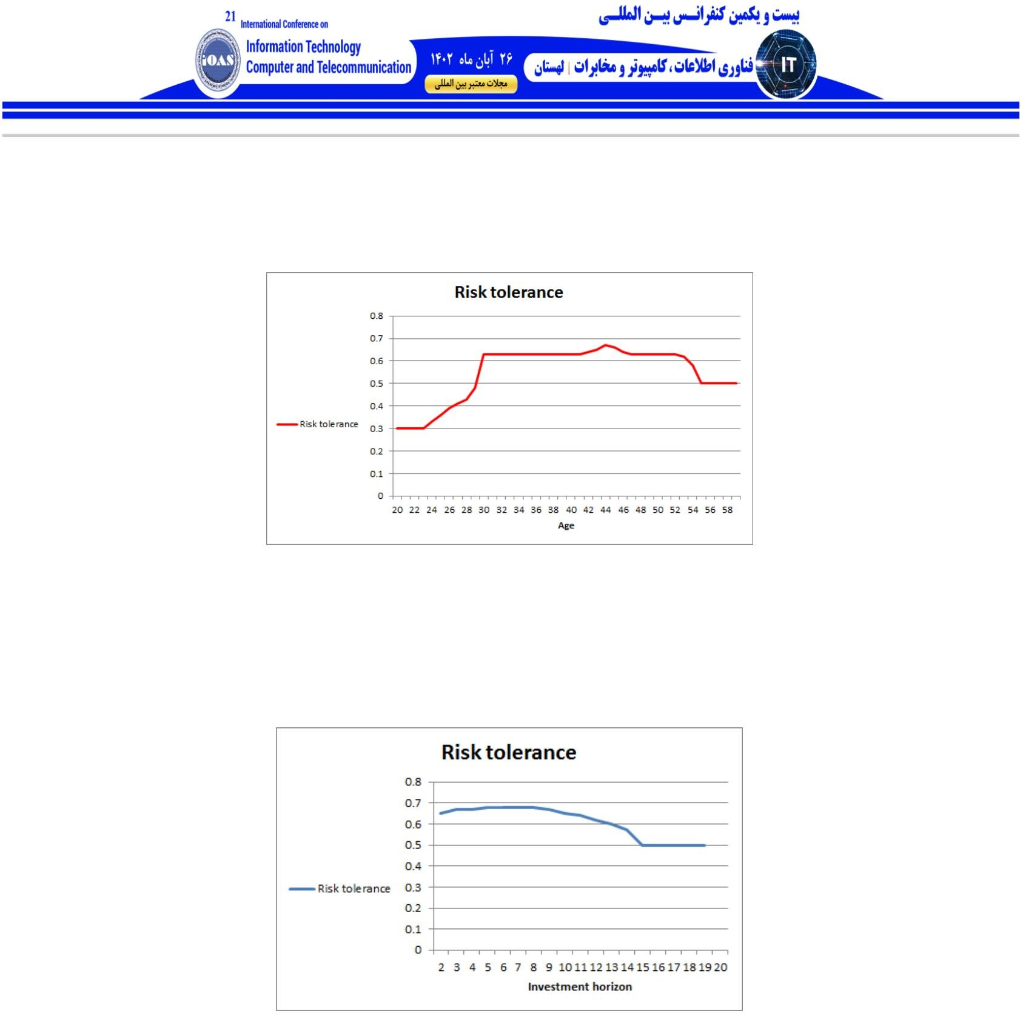

The system was tested for people aged between 20 and 60 years. In this experiment, according to figure (5), it was found that with increasing age, risk tolerance also increases. But this change in the pattern of risk tolerance at older ages (around 45 years and later)

leads to a gradual decrease, which can be attributed to various factors from Among the financial strategies and living conditions of the person.

Figure (5) Test of the proposed algorithm for people aged 20 to 60 years

Then this system was tested for a time horizon between 2 and 20 years. The interesting result is that the risk tolerance increases in the period of 8 to 10 years, but with the increase of time, this amount decreases. According to figure (6), this issue is possible. It is due to

changes in various conditions such as economic conditions or changes in personal conditions.

Figure (6) testing the proposed algorithm for the investment horizon of 2 to 20 years

Finally, this system was tested for the financial situation between two and 100 million (tomans or higher). According to Figure (7), the results showed that with the increase of capital, risk tolerance also increases. This pattern of increasing risk tolerance seems to have no

limits. And the more a person's capital is, the luxury will also increase.

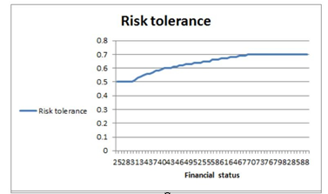

Figure (7) The test of the proposed algorithm for the amount of capital from 2 to 100

million. The present research showed that the use of fuzzy system in financial and investment decisions, especially in relation to risk tolerance, can be an effective tool. These results can be used in decision making processes for Optimizing investment portfolios and risk assessment is useful.

1. **Discussion and conclusion** of the current research based on a fuzzy system for assessing risk tolerance in people and its relationship with age, time horizon, financial status and type The investment was made. The results of this research showed that risk tolerance caused by changes in these factors is associated with certain patterns:
2. With increasing age, risk tolerance also increases. However, after a certain age of about 45 years, risk tolerance decreases and this can be attributed to several factors such as financial or personal issues.
3. The research findings showed that there is a certain period of time that risk tolerance decreases with the increase in the length of this period. After that, the risk tolerance decreases. This issue can be found due to various variables including economic and tax conditions.
4. The results showed that with the increase in investment, risk tolerance also increases. These results can be attributed to various factors such as

import risk, financial market changes and economic policies.

Future works based on the results, future works can include the expansion of research on several other factors such as the individual's personality, the effects of global events on financial markets, or the examination of risk tolerance patterns in specific financial situations. Also, the use of more advanced methods such

as artificial neural networks and deep learning algorithms can be effective in better and more accurate examination of trends and patterns related to risk

tolerance.

**References**

Arthur, P. (2008). The benefits of the crisis. Revue d'économie financier, 461-465.

Chow, G., Kritzman, M., & Van Royen, AS (2001). Risk Budgets: Comment. The Journal of Portfolio Management, 27(4), 109-111.

Grable, J., & Lytton, RH (1999). Financial risk tolerance revisited: the development of a risk assessment instrument. Financial services review, 8(3), 163-181.

Grable, JE, & Roszkowski, MJ (2008). The influence of mood on the willingness to take financial risks. Journal of Risk Research, 11(7), 905-923.

Hansson, SO (2004). Philosophical perspectives on risk. Techné: Research in Philosophy and Technology, 8(1), 10-35.

Hansson, SO (2010). Risk: objective or subjective, facts or values. Journal of risk research, 13(2), 231-238.

Haugh, MB, Iyengar, G., & Song, I. (2015). A generalized risk budgeting approach to portfolio construction. Available at SSRN 2462145

Kermisch, C. (2012). Vers une définition multidimensionnelle du risque. VertigO-la revue électronique en sciences de l'environnement, 12(2).

Lauriola, M., Panno, A., Levin, IP, & Lejuez, CW (2014). Individual differences in risky decision making: A meta- analysis of sensation seeking and impulsivity with the balloon analogue risk task. Journal of Behavioral Decision Making, 27(1), 20-36.

Lee, W., & Lam, DY (2001). Implementing optimal risk budgeting. Journal of Portfolio Management, 28(1), 73.

MacCrimmon, KR, & Wehrung, DA (1986). Assessing risk propensity. In Recent developments in the foundations of utility and risk theory (pp. 291-309). Dordrecht: Springer Netherlands.

Markowitz, H. (1952). The utility of wealth. Journal of political economy, 60(2), 151-158.

Pierandrei, L. (2019). Risk Management. Dunod.

Unger, A. (2014). The use of risk budgets in portfolio optimization. Springer.

Yang, Y. (2004). Characteristics of risk preferences: revelations from Grable & Lytton's 13-items questionnaire. Journal of Personal Finance, 3(3), 20-40.

Yildirim, I. (2015). Financial risk measurement for Turkish insurance companies using VaR models. Journal of Financial Risk Management, 4(03), 158.

Zadeh, LA (1965). Fuzzy sets. Information and control, 8(3), 338-353

Risk tolerance using fuzzy logic: a more accurate method for assessing risk tolerance and optimizing capital portfolios

**AMIRSHAYAN JALILI**

[**SHAYAN138190@GMAIL.COM**](mailto:SHAYAN138190@GMAIL.COM)

**+989101943345**

**Abstract**

This article pays special attention to risk tolerance in decision-making processes, especially in sensitive economic and financial fields. Risk tolerance has traditionally been assessed using precise and predetermined methods and indicators, which may lead to inaccuracies and inefficiencies in important decisions. This is where fuzzy logic as an effective and dynamic tool provides a more efficient approach with a broader and more accurate approach to risk tolerance assessment.

In this article, the application of fuzzy logic in the assessment of people's risk tolerance has been investigated. The use of fuzzy sets and fuzzy inference systems provides a new proposed framework to address the ambiguities and uncertainties associated with risk tolerance. This approach allows for a much more accurate and comprehensive assessment of risk tolerance, and by using fuzzy logic, the incomplete and complex information involved in risk tolerance analysis can be managed more accurately.

The results of this research showed that parameters such as the age of the investor, the investment horizon, the amount of capital and the status of the investor are very effective on the level of risk tolerance, and more importantly, it differs in different periods.

**Keywords:** Fuzzy logic, risk tolerance, risk assessment, decision making, investment